Health and Safety please note

Tower Hamlets Council and London Fire Brigade issue warning after two e-bike fires rip through flats in under 48 hours
Faulty e-bike lithium-ion batteries are believed to have caused two major fires in flats in Limehouse and Aldgate this month.
The first fire took place on Osborn Street in Aldgate on 23 February, the London Fire Brigade (LFB) reported that one bedroom and a hallway in a flat of a five-storey building was completely destroyed. Two men suffering from smoke inhalation were assessed at the scene by the London Ambulance Service.
Only 37 hours later, a second fire was reported on Copenhagen Place in Limehouse, resulting in most of a three roomed flat being in ruins. On 24 February, the LFB received six calls regarding this fire, the first call was made by a resident who was awoken by the fire, which took hold so quickly that the smoke alarms in the property didn't activate.
Four men were assessed at the scene and one man, who was suffering from smoke inhalation, was taken to hospital.
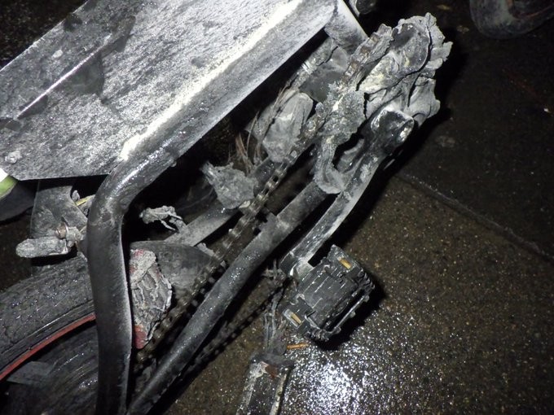
Tower Hamlets Council is warning residents about the risks of e-bike and e-scooter batteries after seeing a rise in related fire incidents in the borough.
Councillor Kabir Ahmed, the Cabinet Member for Regeneration, Inclusive Development and Housebuilding, said:
“It is alarming to hear that these incidents are becoming more frequent in our borough, the safety of our residents is our main priority, and it is clear that we need to tackle this issue now. Our thoughts are with those who have been impacted by these fires, we have been working hard to ensure that any residents who have been displaced due to the incidents are cared for accordingly.
“Unfortunately, these cases are not singular, in November four fire engines and around 25 firefighters tackled a flat fire on Wallwood Street in Poplar. Again, believed to be due to lithium-ion batteries for an e-bike.”
Firefighters issued another safety warning about "incredibly concerning" fires involving e-bikes in London last month. The LFB says it dealt with 88 fires involving e-bikes in 2022, up from 49 a year earlier, which is an 80% increase.
A London Fire Brigade spokesperson said: “It’s incredibly concerning we are continuing to see a rise in incidents involving e-bikes and e-scooters.
“When these batteries and chargers fail, they do so with ferocity and because the fires develop so rapidly the situation can quickly become incredibly serious.
“Lithium-ion batteries are susceptible to failure if incorrect chargers are used and there is a significant risk posed by e-scooters which have been converted.
"We are predominantly seeing fires where batteries have been purchased from online marketplaces and when they've been sourced on the internet, which may not meet the correct safety standards.
“Our advice is to store and charge these items in a safe location if possible, such as in a shed or a garage, and if they have to be stored inside, make sure there is smoke detection fitted and your means of escape is not obstructed.
“However, we know this won’t be possible for everyone, so if you are charging them indoors, please follow our advice on safe charging and ensure everyone in your home knows what to do in the event of a fire.
“We would also suggest people try not to charge them when they are asleep, so that if there is an issue they can react quickly.”
Councillor Kabir Ahmed continues:
“We understand these incidents are accidental however there are actions all e-bike and e-scooter users, and those who live with them, can take to make sure we avoid fires like these happening in the future. Make sure you do not block any fire exit routes or communal walkways with your e-bike whilst it is charging.
“I urge residents to read the advice supplied by the LFB and share widely within your communities and networks, together we can prevent these damaging incidents.”
For more guidance on how to safely charge your e-bike or e-scooter, please read the following article: https://www.london-fire.gov.uk/safety/the-home/e-scooters-and-e-bikes/
Posted on Tuesday 7th March 2023

