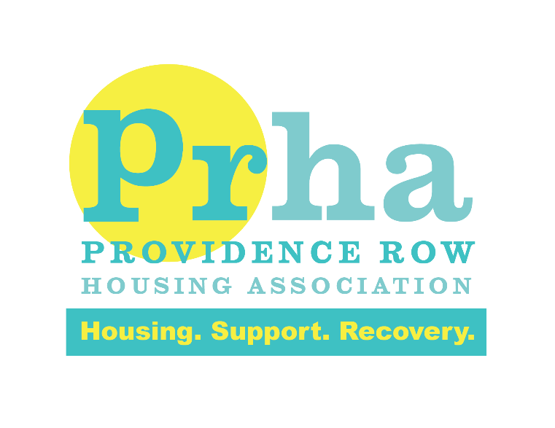
Job Title: Support and Resettlement workers
Location: London Borough of Southwark
Salary: £22,750 rising to £23,205 per annum after successful probation
Hours: 2 full-time posts 40hours per week including weekends
Contract: Permanent Posts
We are recruiting two highly motivated individuals, who are committed to creating a safe and psychologically informed environment, to improve the lives of homeless people.
PRHA hostels guarantee a fast paced, ever changing and ‘no two days are ever the same’ working environment. We are seeking individuals, to join our teams to take on this challenge.
Who we’re looking for
We are looking for self-starters, who are passionate and committed to empowering and supporting residents to achieve their goals, tailored to their individual needs.

To be successful in the role you must be able to demonstrate:

- A strong commitment to providing a high quality person-centered approach to residents with complex needs
- To provide residents with positive experiences, whilst exercising choice and control, to sustain a fulfilling lifestyle
- To be able to work alongside, key stakeholders to ensure residents are receiving the necessary support, in their personal journey
- Ensure at all times the environment is safe and welcoming for all
- Is a team player, possesses a reliable and flexible approach and is willing to embrace all aspects of the role.
What we offer
PRHA was awarded the Investors in People Gold standard for the second time in 2019. This award reflects staff feedback on their development and training opportunities, how they ae valued by PRHA and the support provided to them in fulfilling their roles. We are in the top 3% of housing associations in achieving this award.
Our comprehensive, training and support package will enable you to grow in your career and achieve your professional aspirations.
How to apply

Please read the full Job Description & Person Specification. To apply, please send your CV and Supporting Statement outlining your interest in working for PRHA and explaining how you meet the criteria set out in the Job Description & Person Specification. Please send your CV and Supporting Statement to Tanou Diallo at tdiallo@prha.net by the closing date.
We will only accept CV’s and Supporting Statements with a maximum of 2 pages and Font size 12. Please ensure you send the correct documents by the closing date, as late CV’s and Supporting Statements will not be accepted.
Closing Date
11/06/2021
Interview Date
16/06/2021
It is required for this post that the successful candidates will have to complete an enhanced DBS disclosure check.

